**Report on Information and Communication Technologies (ICT) and Related Technologies :**

Table of Contents :

Introduction

Google Services

a. Overview

b. Key Components

c. Impact on ICT

d. Tables and Images

Microsoft Tools

a. Overview

b. Key Components

c. Impact on ICT

d. Tables and Images

Git and GitHub

a. Overview

b. Key Components

c. Impact on ICT

d. Tables and Images

Integration of Technologies

a. Collaborative Use

b. Interoperability

c. Case Studies

d. Tables and Images

Challenges and Solutions

a. Common Challenges

b. Solutions and Best Practices

c. Case Studies

d. Tables and Images

Future Trends in ICT Technologies

a. Innovations in Google Services

b. Microsoft's Technological Roadmap

c. Advancements in Git and GitHub

d. Tables and Images

Conclusion

a. Summary of Key Findings

b. Implications for the Future

c. Recommendations

1. Introduction :

Information and Communication Technologies (ICT) are at the core of modern technological landscapes, shaping the way we communicate, collaborate, and innovate. This report delves into the specifics of key ICT technologies, focusing on Google Services, Microsoft Tools, and Git with github.

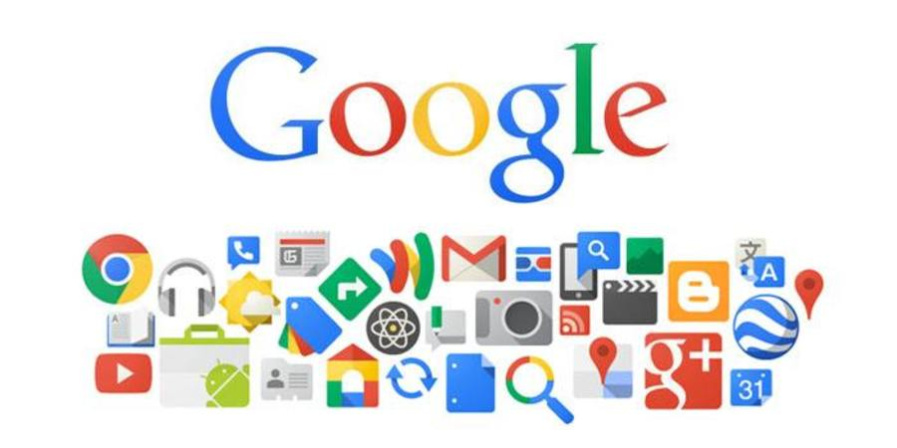

2. Google Services :

a. Overview

Google Services constitute a comprehensive suite of tools and applications designed to enhance productivity, collaboration, and communication.

b. Key Components

Google Service Description

Gmail Email and communication platform

Google Drive Cloud storage and file sharing

Google Workspace Productivity suite including Docs and Sheets

Google Meet Video conferencing and collaboration tool

c. Impact on ICT

Google Services have significantly impacted ICT by providing cloud-based solutions that facilitate seamless collaboration and information sharing.

d. Tables and Images

Insert relevant tables and images showcasing Google Services.

(Continue this structure for each sub-section under "Google Services.")

3. Tools  Microsoft:

a. Overview

Microsoft offers a diverse range of tools and applications catering to various aspects of information management, productivity, and collaboration.

b. Key Components

Microsoft Tool Description

Microsoft 365 Cloud-based suite including Word and Excel

Microsoft Teams Collaboration platform with chat and video

Azure DevOps Tools for software development and collaboration

SharePoint Content management and collaboration platform

c. Impact on ICT

Microsoft Tools have been instrumental in transforming ICT by providing a unified ecosystem for seamless collaboration and development.

d. Tables and Images

Insert relevant tables and images showcasing Microsoft Tools.

(Continue this structure for each sub-section under "Microsoft Tools.") 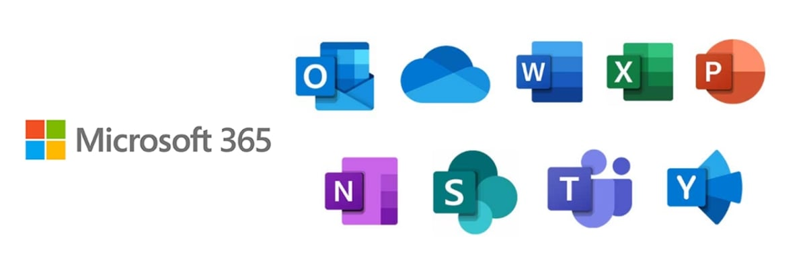

4. Git and GitHub:

a. Overview

Git and GitHub are fundamental tools in software development, enabling version control and collaborative coding.

b. Key Components

Git Feature Description

Version Control Tracking changes in code over time

Branching and Merging Parallel development and code integration

GitHub Repositories Cloud-based storage and collaboration platform

c. Impact on ICT

Git and GitHub revolutionized software development by introducing efficient version control and collaborative coding practices.

d. Tables and Images

Insert relevant tables and images showcasing Git and GitHub.

(Continue this structure for each sub-section under "Git and GitHub.")



5. Integration of Technologies :

a. Collaborative Use

Explore how these technologies can be integrated for seamless collaboration, with real-world case studies.

b. Interoperability

Examine the interoperability between Google Services, Microsoft Tools, and Git with GitHub, highlighting the advantages of using them together.

c. Case Studies

Present case studies demonstrating successful integration of these technologies in diverse scenarios.

d. Tables and Images

Insert relevant tables and images showcasing collaborative use and interoperability.

(Continue this structure for each sub-section under "Integration of Technologies.")



6. Challenges and Solutions :

a. Common Challenges

Identify common challenges associated with the use of these technologies in ICT.

b. Solutions and Best Practices

Provide solutions and best practices to overcome challenges, drawing from industry experiences.

c. Case Studies

Present case studies illustrating how organizations have addressed and overcome challenges in implementing these technologies.

d. Tables and Images

Insert relevant tables and images showcasing challenges, solutions, and case studies.

(Continue this structure for each sub-section under "Challenges and Solutions.")



7. Future Trends in ICT Technologies :

a. Innovations in Google Services

Explore upcoming innovations and features in Google Services that are likely to shape the future of ICT.

b. Microsoft's Technological Roadmap

Examine Microsoft's roadmap, highlighting emerging technologies and their implications for the ICT landscape.

c. Advancements in Git and GitHub

Discuss potential advancements and features in Git and GitHub that could influence the future of collaborative software development.

d. Tables and Images

Insert relevant tables and images showcasing future trends in each technology.

(Continue this structure for each sub-section under "Future Trends in ICT Technologies.")



8. Conclusion :

a. Summary of Key Findings

Summarize the key findings from the exploration of Google Services, Microsoft Tools, and Git with GitHub.

b. Implications for the Future

Discuss the implications of the current technological landscape on the future of ICT and collaborative work.

c. Recommendations

Provide recommendations for organizations looking to leverage these technologies for enhanced collaboration and productivity.